**ICTAS MATERIALS CHARACTERIZATION SHARED FACILITIES**

The Tiedemann Materials Characterization Lab (MCL) is a shared user facility that builds on Virginia Tech's excellence in materials research by providing access to advanced instrumentation to facilitate innovation and discovery.MCL is a shared research facility operated by the [Institute for Critical Technology and Applied Science](https://ictas.vt.edu/) and the [Macromolecules Innovation Institute](https://mii.vt.edu/), with support from the [Office of the Vice President for Research and Innovation](https://www.research.vt.edu/).   
  
A centralized core facility equipped with a range of advanced instrumentation for materials characterization, as well as sample preparation and fabrication, the Tiedemann MCL will facilitate new discoveries in materials science and spark interdisciplinary collaborations within and beyond the Virginia Tech research community.

The BioMaterials Characterization Laboratory (BioMCL) is a new addition to the shared reseaches facilities under the ICTAS. This facility is equipped with high-end microscopy and other tools for characterization of both soft and hard biomaterials. The facility operates in collaboration with the ICTAS and the BEAM department at the Virginia Tech Blacksburg campus.

**Instruments in the Materials Characterization Lab (MCL) for various materials characterization**

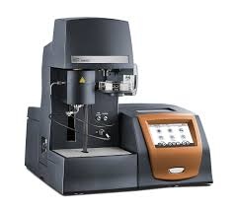**TGA 5500**

**Thermo Gravimetric Analysis (TGA)** with IR furnace (Ambient to 1200 °C) for faster heating and cooling rate, high resolution (<0.1 µg), autosampler for high productivity, Blending Gas Delivery Module (GDM) for flexibility in mixing inter and reactive gases (Nitrogen, Argon, Helium, Air, Oxygen, Carbon Dioxide, Carbon Monoxide and Forming Gas (4%H2/96% N2).

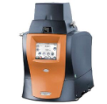**DMA Q850**

**Thermo Gravimetric Analysis (TGA)** Available deformation modes: Dual/single cantilever, 3-point bend, shear sandwich, compression, and film/fiber tension. Liquid nitrogen gas cooling accessory.Temperature range: -145 - 1000 °C

**DSC 5500**

**Thermo Gravimetric Analysis (TGA)**: Materials characterization (Glass transition, Curing, Heat capacity, QC). Temperature range [-120 ̊C to 600 ̊C]. High resolution (1.3 MP vivid color) digital Microscope camera with a magnification of 50-65X for image and video capture during phase transitions. Reliable linear autosampler with programmable tray positions for 24/7 operation, and automated calibration

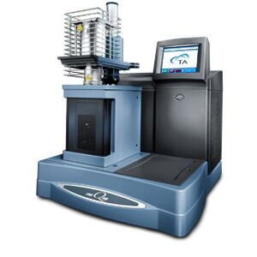**TMA Q400**

**Thermomechanical Analyzers (TMA) to measure the Coefficient of Thermal Expansion (CTE) of materials with respect to temperature under a fixed load. TMA attached with** Refrigerated Cooling System (RCS90) (-90 °C to 550 °C)

**Thermal Conductivity Fox 50**

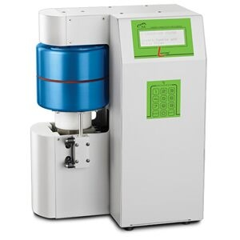

**Accurate, easy-to-use instrument for measuring thermal conductivity according to ASTM C518 and ISO 8301. Temperature range: -10 °C ̊C to 110 °C Thermal conductivity range: 0.1 to 10W/(mK) (0.633 to 60.3BTU in/hr ft2 °F). Thermal resistance range: 0.003 to 0.05 m2K/W. Sample dimensions: Diameter 50 - 62 mm, Maximum Thickness 25 mm**

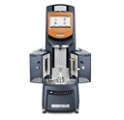

**Discover HR-30 with UV option**

**Discover HR-30 with UV option** to generate Rheological data, under the widest range of measurement conditions (stress-controlled, strain-controlled, or both) w Gap position resolution of 0.02 µm. Peltier Plate option (-40 °C to 200 °C), Environmental Test Chamber (ETC) (up to 600 °C), UV curing accessories.

**Keyence VK-X3000**

The 3D Surface Profilometer has magnification up to 28,800×

Automatic focusing of any materials, Instant, non-contact surface scanning, Easy surface differentiation, Roughness analysis, and Accurate nano-level measurements.

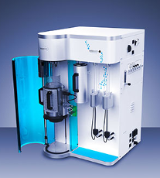**Anton Paar Autosorb iQ C-XR**

High vacuum physisorption/chemisorption analyzers: Extended range physisorption (2 stations) and chemisorption (1 station, Max. furnace temperature: 1100 °C) analyzer. Capable of determining specific surface areas below 0.01 m2/g, active areas, pore volumes, and pore size distributions down to 0.35 nm. Integrated and highly precise sample preparation. The p/p0 Range (XR using nitrogen/argon): 10-8 to 0.999

**Biolin Scientific Theta Flow**

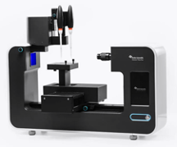

Contact Angle, Surface tension and Interfacial tension measurements. Camera autofocus with automatic surface mapping. 5 MP image quality enhancement with DropletPlus technology and environmental sensors

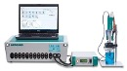**Potentiostat**

Autolab Potentiostat Specially designed for electrochemical impedance spectroscopy, Compliance voltage of 30 V and a bandwidth of 1 MHz, Electrode connections (2, 3 and 4), Potential range (+/- 10 V), Max current +/- 2 A, Current ranges 1 A to 10 nA

**Wide Angle X-Ray Diffraction Bruker D8 Advance**

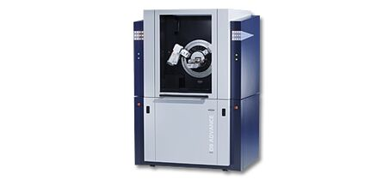

Highlights

* + - TWIN / TWIN optics, Excellent peak-to-background ratio enhances sensitivity for minor phases.
    - Bragg-Brentano for powders and parallel-beam geometry for coatings and thin films (amorphous, polycrystalline and epitaxial) under ambient conditions
    - DIFFRAC.SUITE software for Identification and quantification of crystalline and amorphous phases, Indexing, ab-initio crystal structure determination and crystal structure refinement
    - Grazing incidence diffraction
    - X-Ray Reflectometry

**X-RAY FLUORESCENCE (XRF)**

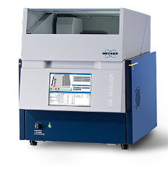

**Bruker S6 JAGUAR**

Wavelength Dispersive X-ray Fluorescence (WDXRF) for elemental analysis, Analytical flexibility for the entire element range (Be – U), 400 W HighSense™ Power: 50 % shorter measurement times with better analytical precision compared to EDXRF, HighSense XE Detection: Full power at 30 kV for light elements and 50 kV for heavy elements.

**Small Angle XRD Xeuss 3.0**

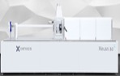 **Xeuss 3.0 SAXS** Characterize the nanostructure of soft-matter and nanomaterials using transmission or grazing incidence mode.Particle size distribution (few nanometers to > 350 nm in diameter)Size and shape analysis of surfactants or proteins in solutions**,** Organization and orientation of nanomaterials at atomic /nanoscale, in bulk phases or at surfaces**,** Phase segregation studies, In situ studies of nanostructure transitions

**VersaLab PPMS**

### A versatile cryogen-free cryocooler system designed for material characterization up to 3 tesla and over a wide temperature range (50 - 400 K). Vibrating Sample Magnetometer (VSM) enables measurement of a sample's magnetic moment as a function of temperature or magnetic field.

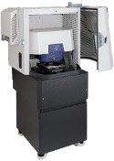O**xford Jupiter XR AFM**

Operating Modes: Contact, Tapping, Nanomechanical, Kelvin Probe Force Microscopy (KPFM), Force Mapping, Conductive AFM (CAFM), Fast Force Mapping, Scanning Capacitance Microscopy (SCM). Operational conditions: Temp stage (-30°C- 300°C), liquid sample holder.

Atomic resolution up to 0.45 nm. Sample size up to 200 mm

**LUMOS II**



**Bruker FT-IR Microscope** Integrated ATR crystal with a multi detector system. Visual resolution in sub micrometer range. Fully Motorized and automated hardware. Accommodate samples up to 40 mm in height. Easy identification and quantification of materials for Microplastics, failure analysis, polymer & plastics, Pharmaceuticals, Industrial manufacturing etc.

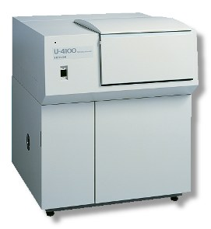

**Hitachi U4100 UV-VIS-NIR**

UV-VIS-NIR system with various integrated spheres for characterization of liquid and solid samples. High-sensitivity integrating sphere produces low-noise measurements from 175 nm to 2600 nm.

**Bruker INVENIO FT-IR Spectrometer**



Spectral range expansion from FIR to UV/VIS. Spectral resolution down to < 0.085 cm-1. Simultaneous FIR/MIR measurements. TGA-IR evolve gas analysis. ATR-IR with Diamond and ZnSe crystals. An extensive library for molecular identification

**Varian 670-IR with mid-IR integrated sphere**

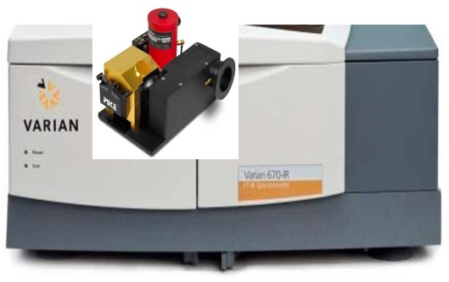

For measuring reflectivity and collecting spectra of solids, analyzing light scattering and/or highly absorbing samples. Full spectral range, from UV (50,000 cm-1) to far-IR (10 cm-1). Mid-band MCT Detector (5000–650 cm-1). Spectral resolution less than 0.07 cm-1.

**XploRA PLUS Raman microscope**

Fully confocal Raman images with versatile laser excitation options. Its SWIFT™ confocal microscopy enables fast and detailed examination of sample composition and structure.

Rapid imaging with excellent detection and sensitivity for precise chemical and structural analysis.

**Instron 3340 Universal Testing System**

Instron 3340 with pneumatic side action grips for Tensile, static and tension-tension cyclic tests for wide range of materials, and compression grips. Single Column Systems are ideal for tension and/or compression studies of materials where tests are less than 2 kN (1,100 lbf) load capacity.

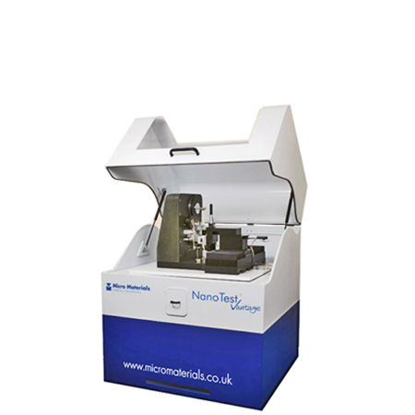**Micro Materials NanoTest Vantage**

Nanomechanical and nanotribological tests including nanoindentation (quasi-static and dynamic), nano-impact and fatigue, nano-scratch and wear, and nano-fretting

Allows testing in a variety of environments including reduced oxygen/purged conditions, under controlled humidity, and in fluid. Temperature range: Ambient - 850 °C

**Instruments in the BioMaterials Characterization Lab (BioMCL) for biomaterials characterization**

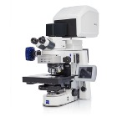**Zeiss LSM 880**

Zeiss LSM 880 (Multiphoton): The Zeiss LSM 880 confocal laser scanning microscope, equipped with a Coherent Chameleon multiphoton (2P) laser, enables advanced imaging through multiphoton excitation while utilizing confocal detectors. This system supports the visualization of non-stained structures via second harmonic generation (SHG) and high-resolution imaging of fluorescently labeled samples.

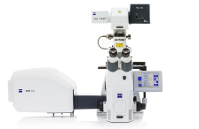**Zeiss LSM 800**

ZEISS LSM 800 confocal laser scanning microscope for high-resolution optical sectioning and imaging of fluorescently labeled samples. It is a Zeiss Axio Observer Z1 inverted microscope. Available with 5x, 10x, 20x, 25x (oil) 40x and 63x (oil) objectives. It features a motorized scanning stage for precise sample movement and a stage-top incubator that controls temperature and CO2 levels, making it suitable for long-duration live-cell experiments.

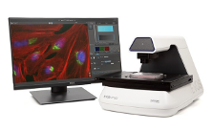**EVOS M7000**

**EVOS M7000 with onstage incubator (OSI-2)**: A fully automated fluorescent and colorimetric imaging system capable of recording time-lapse movies of live cells under physiological and non-physiological conditions (e.g., hypoxia) over extended periods. The EVOS M7000 can scan multiwell plates automatically and features speedy autofocus, image acquisition, and extensive data processing. The system features advanced 2D deconvolution technology that enhances the signal-to-noise ratio (SNR), delivering clear and precise data to uncover subtle details within your samples. It is available with 4x, 10x, 20x, 40x, and 100x objectives to support various imaging needs.

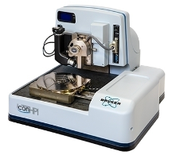

**Bruker Dimension Icon AFM**

Nanoscale imaging and characterization on a large sample tip-scanning AFM platform with temperature-compensating position sensors rendering noise levels in the sub-angstroms range for the Z-axis, and angstroms in X-Y. Nanoscale mapping using various Imaging modes such as Nanomechanical modes, PeakForce modes, Nanochemical, and Nanoelectrial modes. .

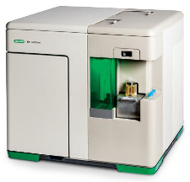**Bio-Rad S3e Cell Sorter**

**Bio-Rad S3e Cell Sorter**: The Bio-Rad S3e Cell Sorter is an automated flow cytometry system for high-speed sorting and analysis of cell populations. Equipped with jet-in-air technology for high-performance cell sorting, enabling the simultaneous sorting of two distinct, predefined populations. It includes automated drop delay calculation and real-time monitoring of droplet break-off to ensure accuracy and consistency. This system is well-suited for sorting cells that express fluorescent proteins or are labeled with fluorescent markers.

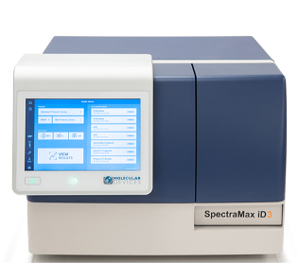 **Molecular Devices SpectraMax® iD3**

Multifunctional microplate reader for various assays, measuring absorbance, fluorescence, and luminescence detection. Equipped with a large touchscreen for easy and intuitive use. The system also offers built-in data analysis capabilities. It features temperature regulation up to 65°C and orbital shaking to accommodate a range of assay types. The SpectraMax iD3 enables both spectral and well-area scanning for comprehensive data collection. Its compact, adaptable design allows for smooth integration into diverse laboratory workflow.

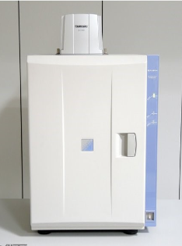**FujiFilm LAS-3000 Luminescent Image Analyzer**

The Fujifilm LAS-3000 is a luminescent image analyzer designed to detect and analyze chemiluminescent and fluorescent signals in biological samples. The LAS-3000 is a high-sensitivity imaging system ideal for capturing clear, detailed images of agarose and polyacrylamide gels, Western blots, and thin-layer chromatography (TLC) plates. Illumination Options include a UV transilluminator for nucleic acid gels, a white transilluminator for protein gels and membranes, and EPI-G LED illumination for fluorescence imaging.

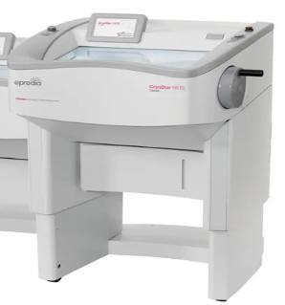**Epredia CryoStar NX70 Cryostat**

A high-precision instrument for rapidly freezing and sectioning biological tissues at low temperatures. It offers superior sectioning quality for a wide range of tissue types. The system features a large, open chamber illuminated by bright, adjustable LED lighting. It includes a high-speed Peltier element for rapid and efficient sample freezing. The cold disinfection system offers a cleaning cycle that minimizes microbial contamination. The light-touch handwheel requires minimal effort, reducing strain from repetitive motion. The instrument supports a sectioning range of 0.5 to 100 μm for fine sections and 5 to 500 μm for trim sections

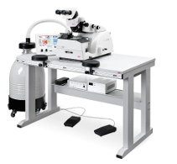

**Leica EM UC7 Ultramicrotome**

Prepare high-quality ultra- or semi-thin sections for transmission electron or light microscope investigation whilst simultaneously creating perfectly smooth block face surfaces for atomic force, scanning electron, or incident light microscopy.

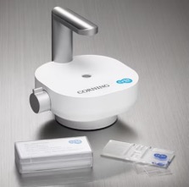**EVOS™ M7000 Imaging System**

**EVOS™ M7000 Imaging System:** Celleste software offers allows automatic cell counting in fluorescence mode post-acquisition.

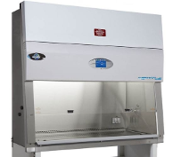**Thermo Fisher 1300 Class II Type A2 Biosafety Cabinet**

Cell Culture & Biological sample Processing Equipment: Biological Safety Cabinets: Offer a sterile and safe environment for handling i sensitive biological samples, essential for research applications.

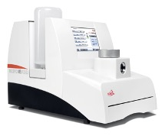

**Leica EM CPD300 Critical Point Dryer**  
The Leica EM CPD300 Critical Point Dryer is a fully automated instrument for drying biological specimens. This advanced system is ideal for preparing samples for SEM (Scanning Electron Microscopy) and Transmission electron microscopy (TEM) analysis, ensuring high-quality preparation with minimal sample distortion..

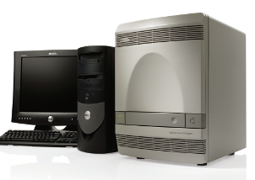**Applied Biosystems 7300 Real-Time PCR System**

The Applied Biosystems 7300 Real-Time PCR System is a platform for detecting and quantifying nucleic acid sequences. This system combines thermal cycling, fluorescence detection, and application-specific software to measure the cycle-by-cycle accumulation of PCR products in a single-tube, homogeneous reaction.

**Technical Experts**

**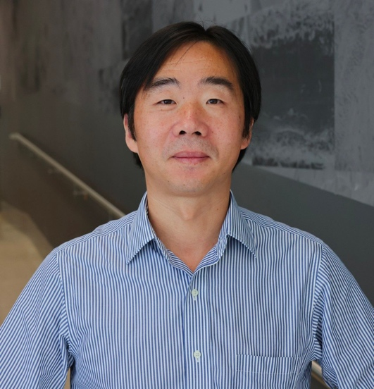  
Dr. Chenggang Tao**

Dr. Tao's research interests span quantum information science, condensed matter physics, and materials physics. He is an expert in microscopy and spectroscopy techniques, including Scanning Tunneling Microscopy (STM), Atomic Force Microscopy (AFM), Transmission Electron Microscopy (TEM), Low Energy Electron Microscopy (LEEM), and Raman spectroscopy. His expertise extends to the synthesis of low-dimensional and quantum materials, device fabrication, ultrahigh vacuum (UHV) systems, and low-temperature techniques.

Dr. Tao has extensive experience in experimentally investigating the structural, electronic, spintronic, and dynamic properties of a variety of condensed matter systems and quantum materials. He has published over 40 papers in top-tier peer-reviewed journals, including Science, Nature Physics, Proceedings of the National Academy of Sciences (PNAS), Physical Review Letters (PRL), J. of the American Chemical Society (JACS), and Nature Communications. For a complete list of his publications, please visit his Google Scholar profile.

<https://scholar.google.com/citations?hl=en&user=L1duIEcAAAAJ&view_op=list_works&sortby=pubdate>

**Contact:** 433 Kelly Hall, [cgtao@vt.edu](mailto:cgtao@vt.edu) , (540) 231-6525 (M)

**Dr. Connor Farrell**

Dr. Connors’s research focuses on designing and developing polymer composite membrane for gas and liquid separations. He has expertise in various hard and soft materials characterization techniques, especially Atomic Force Microscopy, Thermal analysis, and Spectroscopy.

In the role of the Materials Characterization Specialist at the MCL, Dr. Connor trains undergraduate and graduate students on experimental design, instrument operation, and data analysis.

**Contact:** 433 Kelly Hall, [conlf12@vt.edu](mailto:conlf12@vt.edu)

**  
Dr. Rituraj Borgohain**

Dr. Borgohain’s current research focuses on understanding the structure-property relationships of nanomaterials to develop controlled structures, discover new materials, and explore their applications in biomedical and materials engineering. He has expertise in various fields of nanomaterials characterization including carbon-based materials, metal oxides, polymer, polymer composites, biomaterials, surfactants, and industrial chemicals. He also has expertise in industrial Enhanced Oil recovery (WF, CO2, Chemical) processes and laboratory analysis.

As a Core facility research manager, Dr. Rit oversees the operation of MCL and BioMCL, train undergraduate and graduate students, and facilitate interdisciplinary research through these core facilities at the VT for both the academia and other industrial partners and clients.

Google Scholar: <https://scholar.google.com/citations?hl=en&user=pus0pnYAAAAJ>

**Contact:** 429 Kelly Hall, [borgohain@vt.edu](mailto:borgohain@vt.edu), (540) 231-1271 (O)

**  
Dr. Sharad Jaswandkar**

Dr. Sharad’s research focuses on designing and developing biomaterials for bone, brain, and ligament tissue engineering applications. He has expertise in computational molecular modeling of protein-biomaterial, protein-drug interactions, and protein biophysics, designing dynamic in vitro systems, such as bioreactors, for disease modeling.

In the role of the BioMaterials Characterization Specialist at the BioMCL, Dr. Sharad mentor and train undergraduate and graduate students, provide hands-on guidance to support their experimental work, and collaborate with PIs to develop research projects.

Google Scholar: <https://scholar.google.com/citations?hl=en&user=qCcl5nYAAAAJ>

**Contact:** 329 Kelly Hall, [sharadj@vt.edu](mailto:sharadj@vt.edu) , (540) 250-3399 (M)

**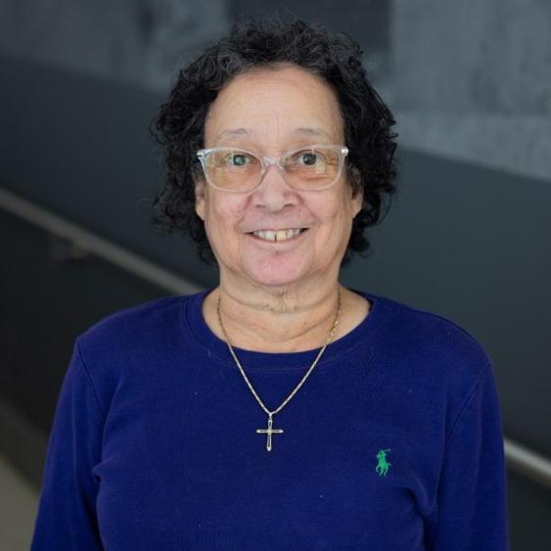  
Kathy Lowe**

As a senior Laboratory specialist, Kathy has over 25+ years of experience with the development and execution of techniques in the areas of electron microscopy, ultra-microscopy and related photography. She is proficient in JEOL100 CXII and Zeiss 10CA transmission electron microscopes, JEOL 35C, Philips 505, Cambridge S90B, and the Zeiss EVO 40 scanning electron microscopes, Balzers BAF 400T freeze fracture apparatus, LKB microtome 4, LKB ultratome NOVA, Riechert-Jung ultracut E, Leica UCT ultramicrotome, RMC 6000-XL ultramicrotome, LKB 7800 knife-maker, Ladd critical point dryer, SPI sputter coater, microcut vibratome, vivaCT 40 Scanco medical scanner. Kathy trains undergraduate and graduate students and provide hands-on guidance to support their experimental work.

**Contact:** 320 Kelly Hall, kjl226@vt.edu